

KARPAGA VINAYAGA
COLLEGE OF ENGINEERING AND TECHNOLOGY
(Approved by AICTE, New Delhi, Affiliated to Anna University, Chennai and Accredited by NAAC ‘A’ Grade)
GST Road, Chinnakolambakkam, Madhuranthagam Taluk, Chengalpattu District – 603 308, Tamil Nadu

2024-2025

INDUSTRIAL INTERNSHIP TRAINING REPORT

Submitted by

MAHESHWARAN J
Register NO: 421223243033
B.Tech Artificial Intelligence And Data Science


KARPAGA VINAYAGA
COLLEGE OF ENGINEERING AND TECHNOLOGY
(Approved by AICTE, New Delhi, Affiliated to Anna University, Chennai and Accredited by NAAC ‘A’ Grade)
GST Road, Chinnakolambakkam, Madhuranthagam Taluk, Chengalpattu District – 603 308, Tamil Nadu

BONAFIDE CERTIFICATE

This is to certify that the Industrial Internship Training titled “CLOUD COMPUTING ” undergone at “ TOP TECH DEVELOPERS ” is the bonafide work of “ MAHESHWARAN J – REG.NO : 421223243033 ” who carried out the training work under my supervision. Certified further, that to the best of my knowledge the work reported here in does not form part of any other project report or dissertation on the basis of which a degree or award was conferred on an earlier occasion on this or any other candidate.

Period of Training: 27/01/2025 – 27/02/2025

SIGNATURE SIGNATURE

HEAD OF THE DEPARTMENT INTERNSHIP COORDINATOR
Department of Artificial Intelligence And  DataScience | Department of Artificial Intelligence And DataScience
Karpaga Vinayaga College of | Karpaga Vinayaga College of
Engineering and technology, | Engineering and technology,
Chinna Kolambakkam, | Chinna Kolambakkam,
Maduranthagam TK, Padalam, | Maduranthagam TK, Padalam,
Chengalpattu-603308. | Chengalpattu-603308.

INTERNSHIP CERTIFICATE

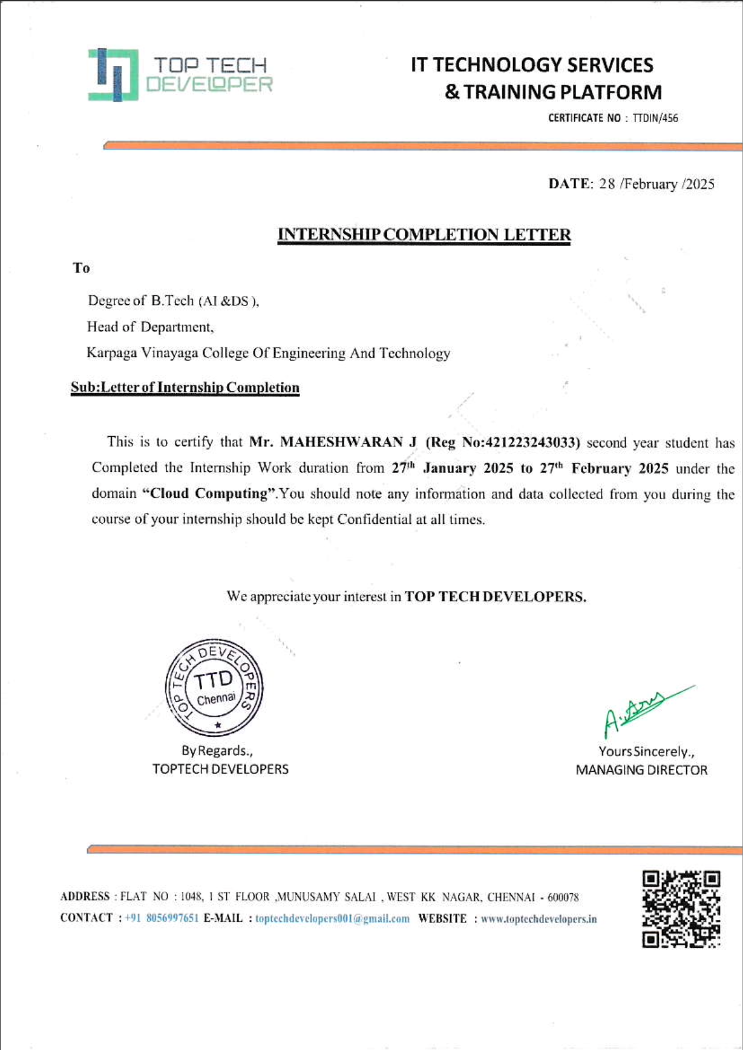

DECLARATION

I “MAHESHWARAN J REG.NO : 421223243033 ” hereby declare that the internship entitled “ CLOUD COMPUTING ” undergone at “ TOP TECH DEVELOPERS , CHENNAI” being submitted in partial fulfilment of the requirements for the award of the Degree of “B.TECH ARTIFICIAL INTELLIGENCE AND DATA SCIENCE ” is the original work carried out by me. It has not formed the part of any other project work submitted for award of any degree or diploma, either in this or any other Institution.
Period of Training: 27/01/2025 – 27/02/2025

Signature

Place: Chennai Name: MAHESHWARA J
REG.NO: 421223243033
Date: 10/03/2025

CO- PO & PSO MAPPING

CO1: Participate in the projects in industries during his or her industrial training.
CO2: Describe use of advanced tools and techniques encountered during industrial training.
CO3: Interact with industrial personnel and follow engineering practices and discipline prescribed in industry.
CO4: Develop awareness about general workplace behavior and build interpersonal and team skills.
CO5: Learn and adopt the engineer’s role and responsibilities with ethics
CO6: Prepare professional work reports and presentations.

 | PO1 | PO2 | PO3 | PO4 | PO5 | PO6 | PO7 | PO8 | PO9 | PO10 | PO11 | PO12 | PSO1 | PSO2
CO1 | 3 | 3 | 3 | 3 | 3 | 3 | 3 | 3 | 3 | 3 | 3 | 3 | 3 | 3
CO2 | 3 | 3 | 3 | 3 | 3 |  |  |  |  |  |  | 1 | 1 | 3
CO3 |  |  |  |  |  | 3 | 1 | 3 | 3 | 3 | 1 | 1
CO4 |  |  |  |  |  | 1 | 1 | 3 | 3 | 3 | 1 | 1
CO5 |  |  |  |  |  | 3 | 1 | 3 | 3 | 3 | 2 | 1 | 1
CO6 |  |  |  |  |  |  |  | 3 | 3 | 3 | 2 | 1

EXECUTIVE SUMMARY

I had the opportunity to complete my internship at Top Tech Developers Chennai , a leading
software development and training company specializing in IT solutions, web development,
and software engineering. The organization provides hands-on training for students and professionals, equipping them with industry-relevant skills. This internship helped me bridge
the gap between academic learning and real-world application by working on a practical project.

INTERNSHIP RESPONSIBILITIES
During the internship, my primary responsibility was to work on the Memory Leak Detection System, specifically utilizing the memleak_detector project. The internship focused on detecting and analyzing memory leaks in system performance logs, which is critical for maintaining system stability.
KEY TASKS INCLUDED
- Setting up the development environment: Installed necessary dependencies and configured the memory leak detector tool.
- Data Analysis & Processing: Worked with CSV datasets containing system memory usage logs, cleaning and preparing them for analysis.
- Executing Detection Scripts: Ran memleak4.py and my_testline_monitor.py to analyze memory usage trends and identify potential leaks.
- Customizing the Tool for Real-Time Monitoring: Modified the scripts to integrate real-time log analysis, improving efficiency in leak detection.
- Automating Alerts & Reporting: Implemented an alert system that notifies system administrators upon detecting memory leaks.

RESULTS ACHIEVED
The internship provided valuable experience in system monitoring and performance analysis. The project led to the following key results:
- Successful detection of memory leaks in test environments.
- Integration of real-time data monitoring, enhancing detection efficiency.
- Automation of alert notifications, ensuring quick responses to potential issues.
- Improved system reliability by reducing memory-related crashes and inefficiencies.
This experience not only strengthened my Python programming, data analysis, and debugging skills but also provided insights into real-world IT system management and optimization. The project’s findings contributed to improving the overall system performance and resource utilization for the company.

ACKNOWLEDGEMENT

First, I would like to thank , Ms Gayathri MD, of Top Tech Developers Chennai for giving me the opportunity to do an internship within the organization.

With profound gratitude and due regards, I whole heartedly and sincerely acknowledge with thanks the opportunity provided to me by our respectful Director Dr. Meenakshi Annamalai, for the facilities provided to accomplish this internship.

I thank our dedicated Principal, Dr. P. Kasinatha Pandian, for his valuable suggestion and timely advice which helped me in completing the internship.

I am grateful to our Dean Dr. L. Subbaraj, for his effective advice and support for the planning and processing of the internship.

I thank our respectable Head of the Department, Dr. S. Dinesh Kumar, for his continuous encouragement and valuable insights that greatly enhanced my internship experience.

I wholeheartedly thank my respectable Internship Coordinator, Mr. R. Prem Kumar, for his unrelenting support, without proper guidance this internship could not have been completed.

I thank various faculty members and friends for their timely help and guidance in one way or other, which went a long way in the completion of this internship.

MAHESHWARAN J REG.NO : 421223243033

PREFACE

As a student of the Department of Artificial Intelligence and Data Science , I am required to undertake an industrial internship to enhance my knowledge and skills. The purpose of this internship is to acquaint me with the practical applications of theoretical concepts taught during my course period. This internship provided a valuable opportunity to compare theoretical concepts with practical experiences in the field.

This report is a culmination of my efforts and may reflect some deficiencies, but it accurately represents my learning experience. The report summarizes the output of my analysis and outlines the sequence of events during my internship.

I have prepared this report as a requirement for my first industrial internship. As an aspiring engineer, I aim to utilize my knowledge to invent innovative solutions that can help society overcome problems. To achieve this goal, I am working with Top Tech Developers located at Vadapalani ,Chennai District.

ABSTRACT

Memory leaks can cause system slowdowns and crashes by consuming excessive resources. This project implements a Memory Leak Detection System using memleak_detector, which analyzes system memory usage and detects leaks. The system processes memory logs, identifies anomalies, and sends automated alerts to prevent performance issues. Real-time monitoring and data visualization enhance detection accuracy. The project improves system reliability and provides a foundation for future enhancements like AI-driven predictive analysis.

KEY OBJECTIVES
1. Analyze system memory logs to identify unusual memory consumption.
2. Implement real-time monitoring to detect leaks proactively.
3. Develop an automated alert system to notify administrators.
4. Visualize memory trends using graphs for better analysis.
5. Optimize detection scripts to improve accuracy and reduce false positives.

METHODOLOGY
- Data Collection: System logs are analyzed for memory consumption trends.
- Detection Algorithm: The tool is used to identify abnormal memory usage.
- Real-Time Implementation: The system continuously tracks live memory data.
- Automation & Alerts: Notifications are triggered upon detecting a potential leak.

RESULTS & IMPACT
- Improved system reliability by preventing memory-related failures.
- Enhanced performance monitoring through automated detection.
- Reduced manual debugging efforts with automated alerts.
- Optimized resource management for better efficiency.
This system provides a scalable and efficient solution for memory leak detection, contributing to better system performance, stability, and resource utilization. Future enhancements can include AI-driven predictive analysis and integration with cloud monitoring platforms for broader applications.

TABLE OF CONTENT

CHAPTER NO. | TITLE | PAGE NO.
 | Bonafide Certificate | ii
 | Company Certificate | iii
 | Declaration | iv
 | CO- PO & PSO Mapping | v
 | Executive Summary | vi
 | Acknowledgment | vii
 | Preface | viii
 | Abstract | ix
1. | Introduction | xi
 | 1.1 Background | xi
 | 1.2 Objectives | xi
 | 1.3 Scope | xi
2. | Profile | xii
 | 2.1 Industry Profile | xii
 | 2.2 Industry Culture | xii
3. | Weekly Overview of the Internship Activities | xiii
 | 3.1 Internship Duration, Department &Industry Supervisor Details | xiv
 | 3.2 Responsibilities | xiv
4. | Project | xv
5. | Skills Acquired | xvii
6. | Conclusion | xix
 | References | xix

Chapter – 1

INTRODUCTION

BACKGROUND
Memory leaks are a critical concern in software systems, leading to performance degradation, excessive resource consumption, and potential system crashes. Undetected memory leaks can result in slow application performance, increased maintenance costs, and even security vulnerabilities. Addressing these issues is crucial for ensuring stable, high-performing, and scalable software solutions. This project focuses on building an intelligent and automated Memory Leak Detection System using memleak_detector, which provides real-time monitoring, in-depth analysis, and proactive resolution of memory-related problems.

ADJECTIVE
This project is cutting-edge, adaptive, and performance-driven, designed to enhance efficiency, reliability, and scalability in software systems. It leverages intelligent automation to provide a proactive approach to memory management, ensuring early detection and resolution of issues before they escalate. The solution is highly efficient, precise, and resilient, capable of handling complex memory leak scenarios across various software environments. It is also robust, data-driven, and future-ready, making it an ideal tool for optimizing system performance while reducing downtime and resource wastage. By integrating real-time tracking, automation, and advanced log analysis, this project offers a comprehensive, intelligent, and scalable solution for memory leak detection and system optimization.
SCOPE
The scope of this project includes:
- Detecting and diagnosing memory leaks in software applications using automated tools.
- Implementing real-time monitoring to track memory usage patterns and anomalies.
- Developing automated alerts and logging mechanisms to proactively address memory issues
- Optimizing system performance and stability by preventing excessive memory consumption.
- Enhancing scalability and reliability by ensuring efficient resource allocation.
Future advancements may include machine learning-based predictive analytics, cloud-integrated monitoring, and AI-driven anomaly detection, making it a highly adaptable, intelligent, and industry-relevant solution for software performance optimization.

Chapter – 2

PROFILE

INDUSTRY PROFILE
The company operates in the IT and software development industry, with a strong focus on system performance optimization, cybersecurity, and automation solutions. It specializes in developing tools for memory management, log analysis, and real-time system monitoring to enhance software reliability and efficiency.
Key areas of expertise include:
- Software Performance Monitoring – Identifying and resolving system bottlenecks.
- Memory Management Solutions – Detecting and preventing memory leaks.
- Cybersecurity & System Stability – Ensuring secure and optimized operations.
- AI & Automation – Implementing AI-driven monitoring solutions for proactive issue detection.
The company provides solutions to enterprises, software developers, and IT infrastructure teams to help maintain efficient and scalable systems.

COMPANY CULTURE
The organization promotes a collaborative, innovative, and learning-driven culture where employees and interns are encouraged to experiment, problem-solve, and contribute to real-world projects. Key aspects of the work culture include:
- Innovation-Driven Environment – Encouraging creative problem-solving and research.
- Collaboration & Teamwork – Cross-functional teams work together on projects.
- Continuous Learning – Employees have access to training, mentorship, and hands-on experience.
- Adaptability & Growth – The company embraces emerging technologies and industry trends.
- Work-Life Balance – A flexible and supportive work environment that values employee well-being.
This dynamic work culture helps in fostering creativity, enhancing technical expertise, and preparing interns for future career opportunities in the tech industry.

Chapter – 3

WEEKLY OVERVIEW OF THE INTERNSHIP ACTIVITIES

1st Week | Date | Day | Work done
 | 27/01/2025 | Monday | • Introduction to the company and project overview.  • Discussion with the mentor on objectives and expectations.  • Setting up the development environment (Python,Git,dependencies).
 | 28/01/2025 | Tuesday | • Studying the memleak_detector GitHub repository.  • Understanding the memleak4.py and my_testline_monitor.py scripts.  • Exploring sample data (.csv files) for memory analysis.
 | 29/01/2025 | Wednesday | • Running the memory leak detection scripts on sample datasets.  • Understanding output logs and detecting anomalies.
 | 30/01/2025 | Thursday | • Experimenting with different datasets to refine memory leak detect  • Understanding memory usage trends in logs.  • Identifying possible causes of false positives in detection.
 | 31/01/2025 | Friday | • Researching best practices for memory leak detection in system logs  • Discussing potential improvements with the mentor.

2nd Week | Date | Day | Work done
 | 03/02/2025 | Monday | • Modifying detection scripts for better accuracy.  • Testing scripts on new memory usage datasets.  • Debugging issues related to trend analysis.
 | 04/02/2025 | Tuesday | • Implementing logging mechanisms to store detected memory leaks.  • Adding more visual representation (graphs) using Matplotlib.  • Testing and documenting improvements.
 | 05/02/2025 | Wednesday | • Studying system monitoring tools (Docker, Kubernetes) for integration.  • Exploring real-time data streaming methods.  • Planning the next steps for real-time implementation.
 | 06/02/2025 | Thursday | • Implementing real-time memory monitoring using logs.  • Writing scripts to fetch live system memory data.
 | 07/02/2025 | Friday | • Integrating real-time logs with the detection script.  • Running tests on live system logs.

3rd Week | Date | Day | Work done
 | 10/02/2025 | Monday | • Researching alerting mechanisms (email, Slack, webhook notifications).  • Designing an automated notification system for leak detection.
 | 11/02/2025 | Tuesday | • Implementing email-based alert notifications.  • Testing and debugging the alert system.
 | 12/02/2025 | Wednesday | • Enhancing alerts with severity levels (low, medium, high leaks).  • Testing on different datasets.
 | 13/02/2025 | Thursday | • Reviewing automation performance.  • Addressing false alarm issues in the alert system.
 | 14/02/2025 | Friday | • Running final tests on the automation system.  • Writing test cases for memory leak detection.

4th Week | Date | Day | Work done
 | 17/02/2025 | Monday | • Reviewing all implemented features.  • Testing scalability with large datasets.
 | 18/02/2025 | Tuesday | • Identifying areas for improvement.
 | 19/02/2025 | Wednesday | • Refining the detection script for optimization.  • Improving logging and data visualization.
 | 20/02/2025 | Thursday | • Conducting performance benchmarking.  • Measuring execution time and optimizing code.
 | 21/02/2025 | Friday | • Testing real-time logging accuracy.

5th Week | Date | Day | Work done
 | 24/02/2025 | Monday | • Presenting the project to the mentor/team.  • Collecting feedback and discussing improvements.
 | 25/02/2025 | Tuesday | • Implementing final fixes based on feedback.  • Reviewing alert system effectiveness.
 | 26/02/2025 | Wednesday | • Writing key takeaways from the project.
 | 27/02/2025 | Thursday | • Submitting the final project and report.  • Exit interview and feedback session.

Chapter – 4

PROJECT

PROJECT OVERVIEW
Memory leaks are a common issue in software applications, causing gradual performance degradation, increased resource consumption, and potential system failures. This project focuses on developing a Memory Leak Detection System using memleak_detector to analyze memory usage trends, detect anomalies, and provide real-time alerts. By implementing automated monitoring, this system helps in early detection and prevention of memory-related issues, ensuring better system performance and stability.

OBJECTIVES
The main objectives of this project are:
- Detect memory leaks by analyzing system memory usage.
- Implement real-time monitoring for proactive leak detection.
- Develop an automated alert system to notify administrators.
- Visualize memory trends for better understanding and analysis.
- Optimize detection algorithms to reduce false positives.

TECHNOLOGIES USED
- Python – For scripting and automation.
- Memleak Detector – Open-source tool for memory leak detection.
- Log Analysis Tools – To interpret memory usage patterns.
- Automation & Alert Systems – For real-time notifications.
- Data Visualization (Matplotlib, Dashboards) – For graphical analysis of memory trends.

PROJECT IMPLEMENTATION
- Setup & Environment Configuration – Installing memleak_detector and configuring system logs.
- Data Collection & Analysis – Extracting memory usage patterns from system logs.
- Implementation of Detection Scripts – Developing Python scripts to analyze memory trends.
- Real-Time Monitoring & Alerts – Setting up automation to trigger alerts for anomalies.
- Visualization & Reporting – Creating dashboards for better insights.
- Optimization & Testing – Reducing false positives and improving detection accuracy.

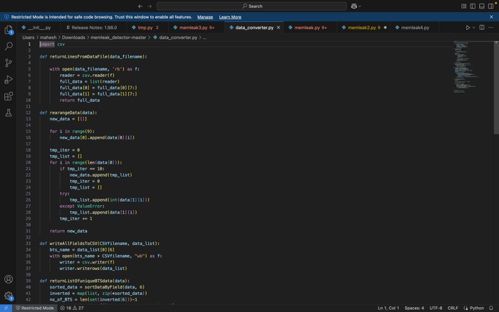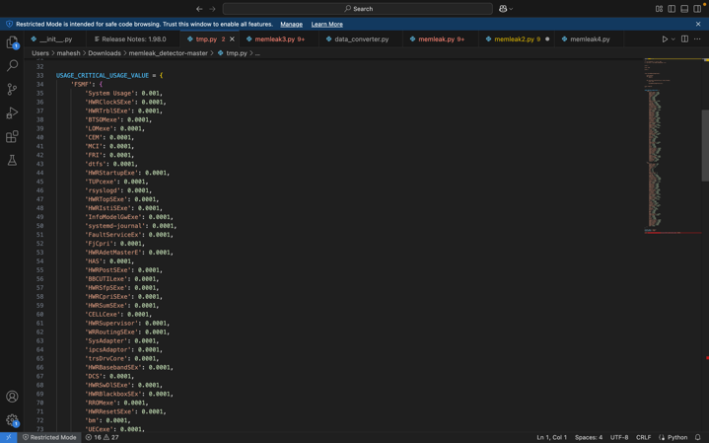

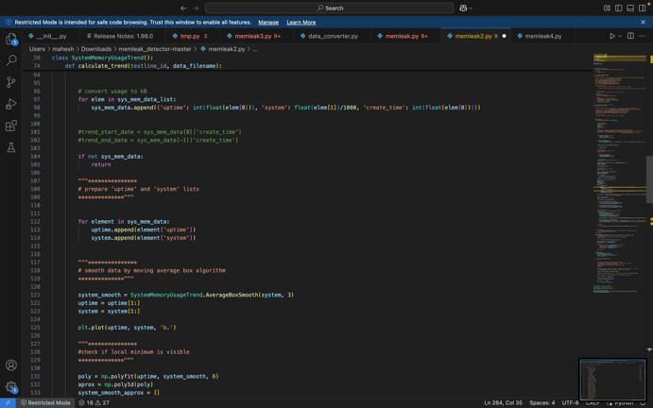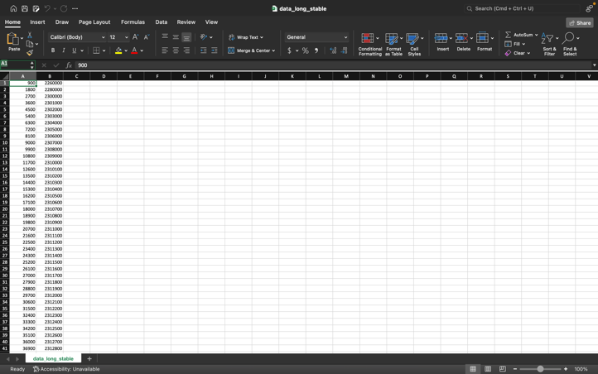

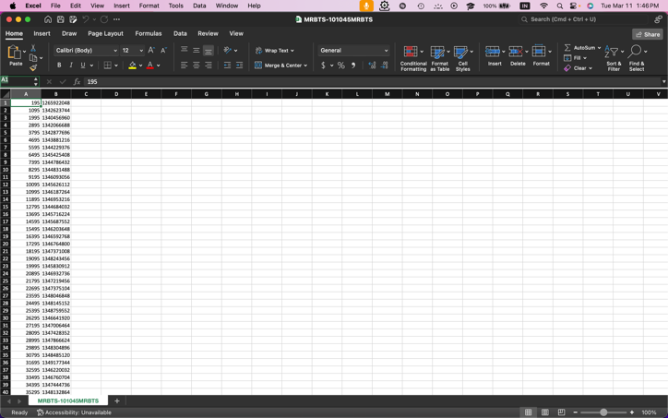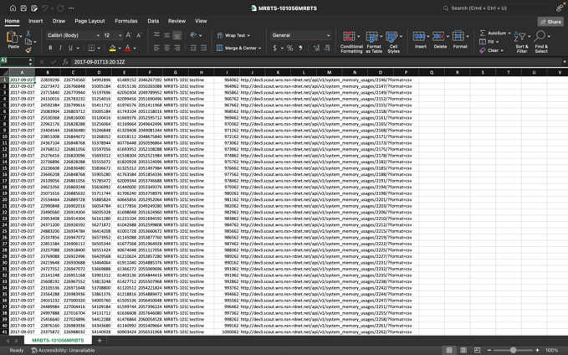

Chapter – 5

SKILLS ACQUIRED

During this internship, I gained valuable technical and professional skills that enhanced my understanding of memory management, system monitoring, and performance optimization.

TECHNICAL SKILLS:
- Memory Leak Detection – Identifying and analyzing memory leaks using memleak_detector.
- Python Programming – Writing scripts for log analysis and automation.
- Log Analysis – Extracting and interpreting system memory usage data.
- Real-Time Monitoring – Implementing continuous tracking for proactive detection.
- Performance Optimization – Enhancing system stability by reducing memory leaks.
- Automation & Alerts – Developing automated notification systems for anomalies.
- Data Visualization – Using Matplotlib to represent memory trends graphically.

PROFESSIONAL SKILLS:
- Problem-Solving – Troubleshooting and resolving memory-related issues efficiently.
- Critical Thinking – Analyzing data to optimize detection algorithms.
- Collaboration – Working in a team environment for effective project execution.
- Time Management – Balancing multiple tasks within project deadlines.
- Documentation – Preparing technical reports and project documentation.
This internship provided a strong foundation in system performance monitoring and automated diagnostics, preparing me for future roles in software development and system administration.

Chapter – 6

CONCLUSION
This project successfully implemented a Memory Leak Detection System to identify and mitigate memory leaks, ensuring better system performance, stability, and resource optimization. By integrating real-time monitoring, log analysis, and automated alerts, the system proactively prevents memory-related failures.
The project enhanced my technical expertise in Python, log analysis, and system monitoring, while also developing problem-solving, collaboration, and time management skills. The experience gained during this internship will be valuable for future endeavors in performance optimization, system diagnostics, and IT infrastructure management.
Future improvements to this project could include AI-driven predictive analysis, cloud-based monitoring, and enhanced machine learning models for better anomaly detection. This internship has been an enriching experience, providing practical exposure to real-world system monitoring challenges.

REFERENCES

• Marek Biczysko, memleak_detector, GitHub Repository: https://github.com/MarekBiczysko/memleak_detector

• Python Documentation – https://docs.python.org/

• Matplotlib Documentation – https://matplotlib.org/stable/contents.html

• System Performance Monitoring – Research Paper, IEEE Xplore

• Log Analysis for System Health, ACM Digital Library

